**Solution for TestNG Installation error**

1. Download the source code(anyone from download) from the github : [testNG Source in Git](https://github.com/cbeust/testng-eclipse/blob/master/README.md" \l "building) and take any version that suits your needs as below

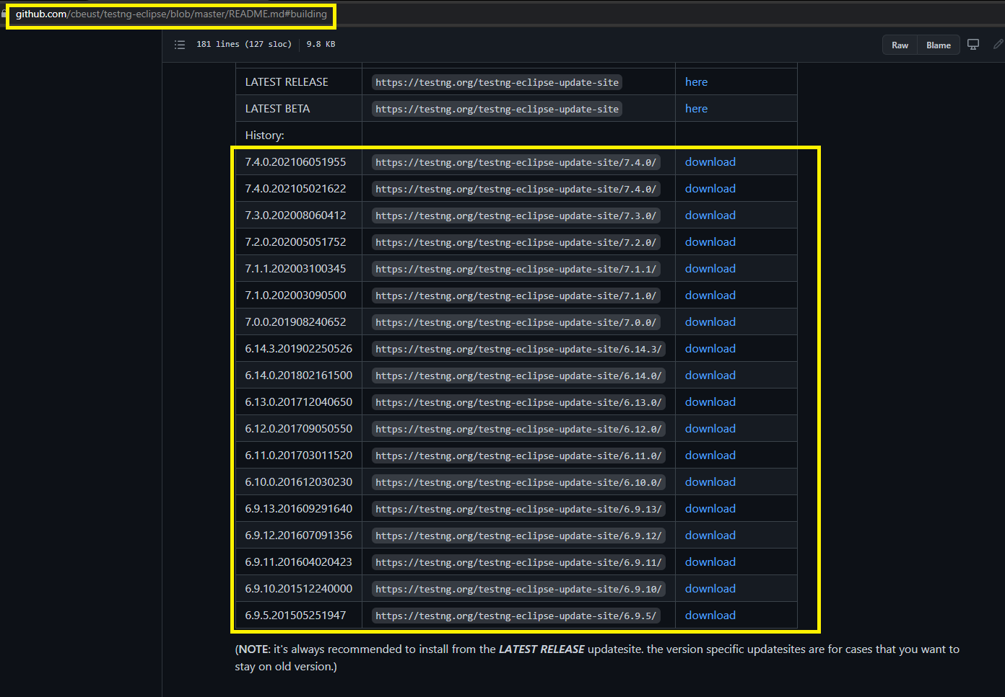

1. Once downloaded extract the folder to eclipse directory: Let's assume hypothetically you have kept it in **C:** drive, then the path where you would extract is: **C:\eclipse\dropins** : Preferably use **7zip** extractor to unzip it to directory.

Downloaded Zip file🡪Copy to **C:\eclipse\dropins** and extract



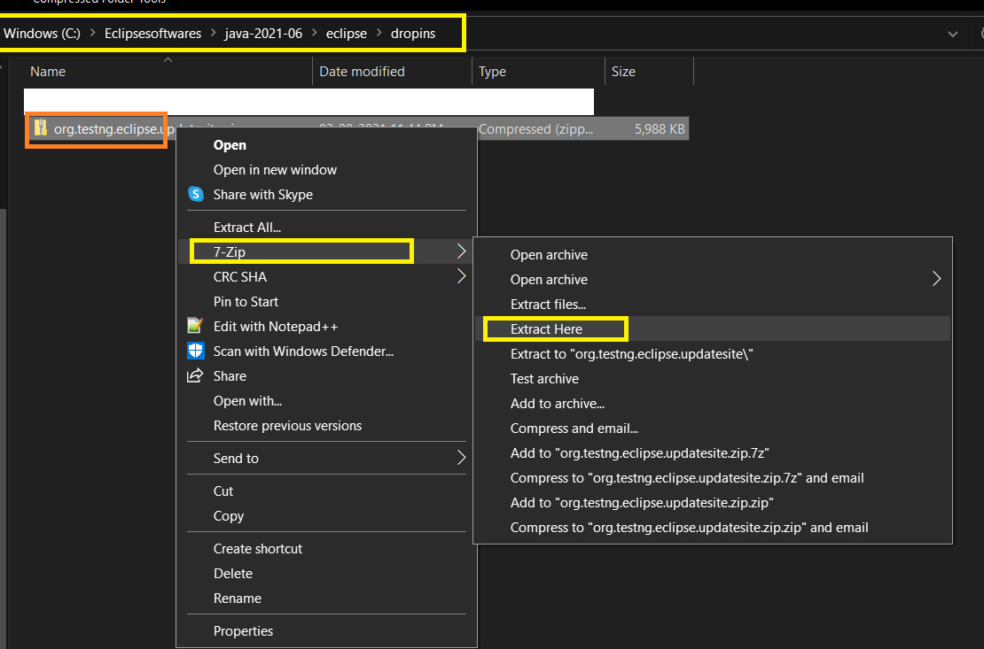

1. **Extracted folder in dropins**

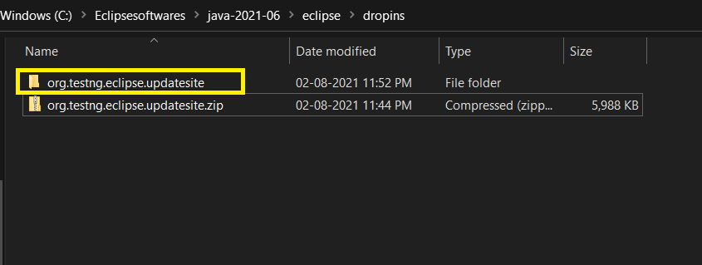

1. **Extracted folder contents**

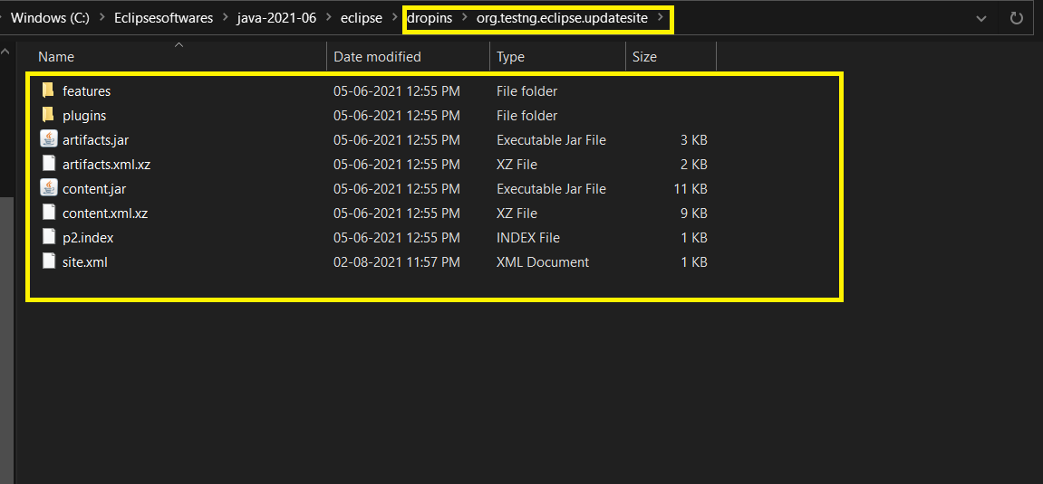

1. Once extracted, you need to add one file to the folder: **site.xml**. Create a site.xml file and add the below details: and where ever **<TestNG_Version_downloaded>** is quoted, please don't forget to add the TestNG version downloaded.

**Add below xml code in a note pad and save as site.xml**

<?xml version="1.0" encoding="UTF-8"?>

<site>

<feature url="features/org.testng.eclipse**_<TestNG_Version_downloaded>.**jar" id="org.testng.eclipse" version**="<TestNG_Version_downloaded>**">

<category name="org.testng.eclipse"/>

</feature>

<feature url="features/org.testng.eclipse.maven.feature_7.0.0.201908240652.jar" id="org.testng.eclipse.maven.feature" version="**<TestNG_Version>**">

<category name="org.testng.eclipse"/>

</feature>

<category-def name="org.testng.eclipse" label="TestNG"/>

**Now edit the TestNG version downloaded in above xml file**

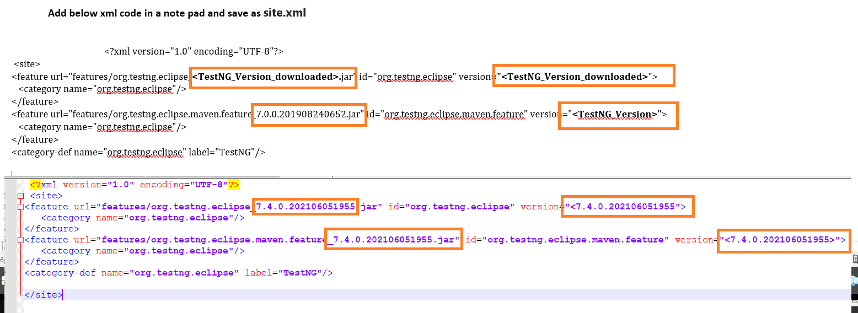

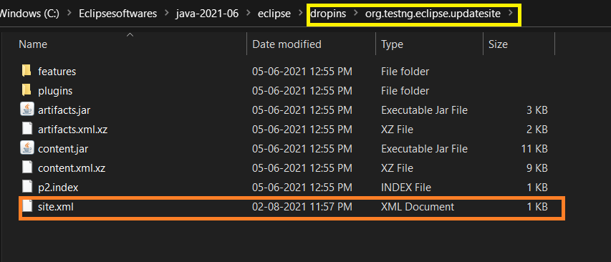

1. Once Everything is done: Go to Eclipse, and perform **ctrl+N** and you can see testNG appearing in the menu and that's it and you are ready to use TestNG. Happy Coding!!

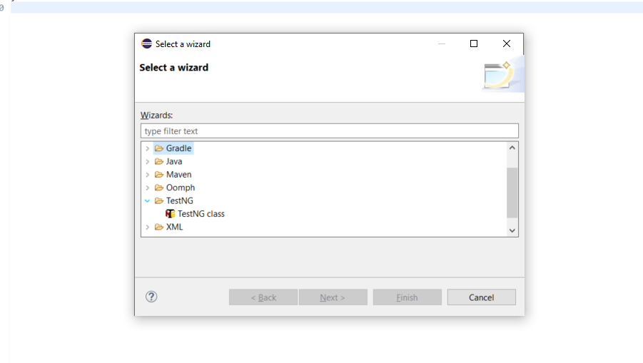

**Also you can see the TestNG in Project---right click**

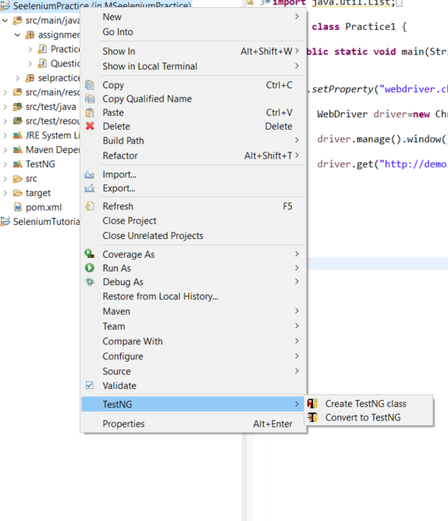

**Just check TestNG option is available in this way also**

**Window—Show View—Other🡪Java folder--TestNG**

